**Project Setup:**

This project was made using ReactJS with React Bootstrap styling. To run this project, you will need yarn installed. Then navigate to the project folder in your terminal and run "yarn install” in order to install the project’s necessary dependencies. Once this has completed, enter “yarn start” in the terminal to host the project locally (localhost:3000 in your browser).

**Project Features:**

To get the current weather, the user should input a city name and select a state in the dropdown menu, or they can enter a zip code. The use of the dropdown menu decreases the possibility of user error in inputting a state name. After filling in the fields, the user can choose between Fahrenheit and Celsius for the weather results. Hitting the search button will make an API call to OpenWeather, before displaying the results below the search bar.

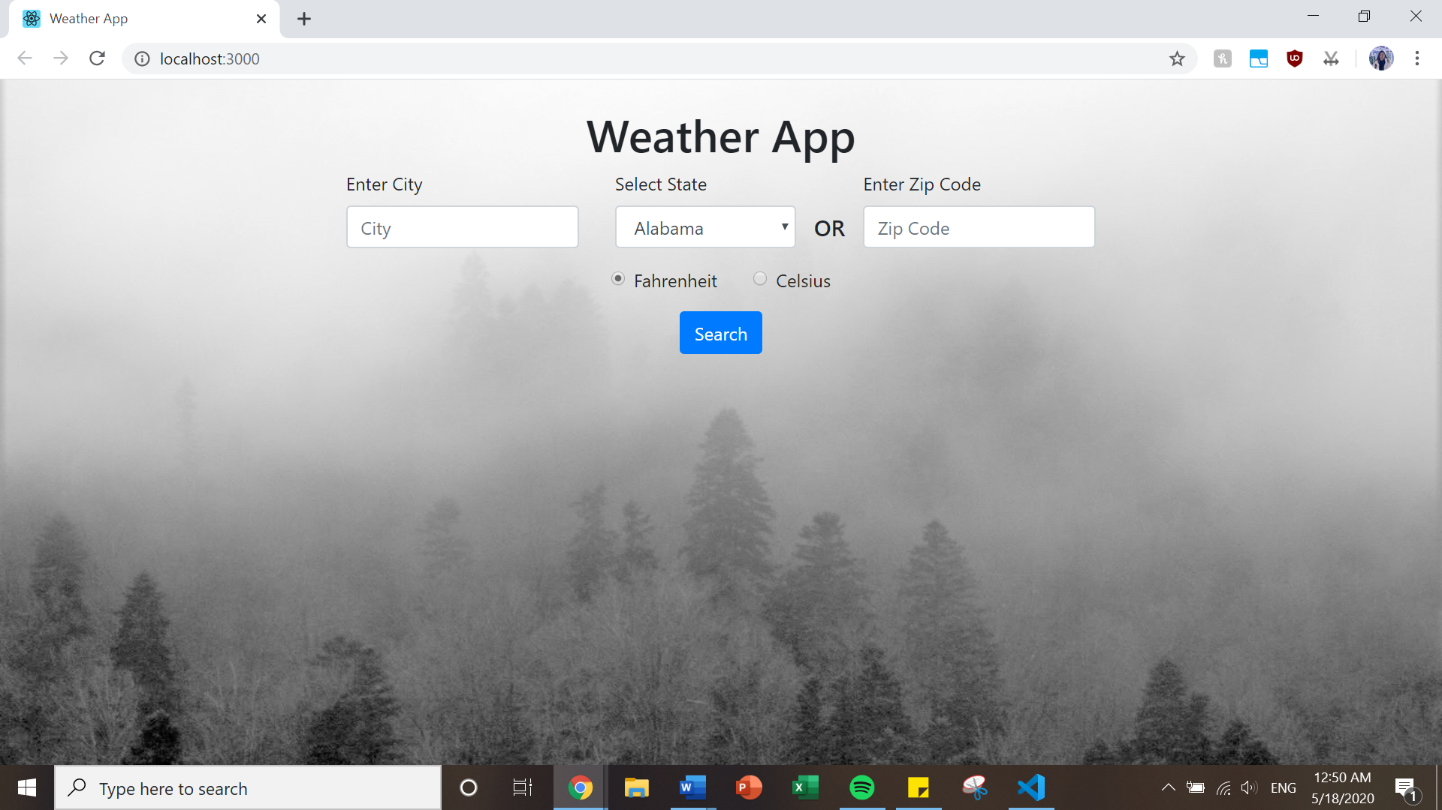

City, State Input:

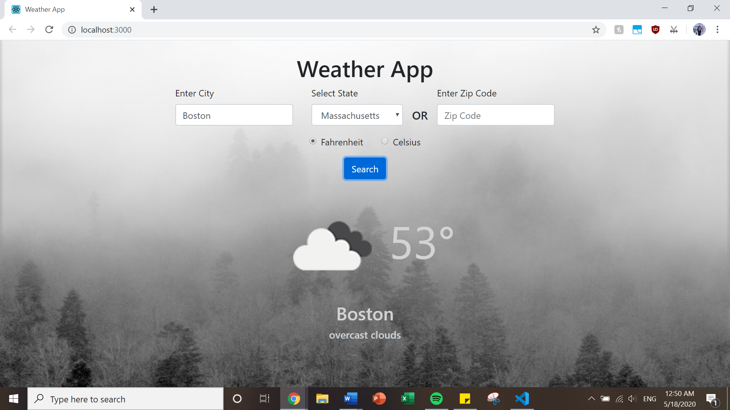

Zip Code Input:

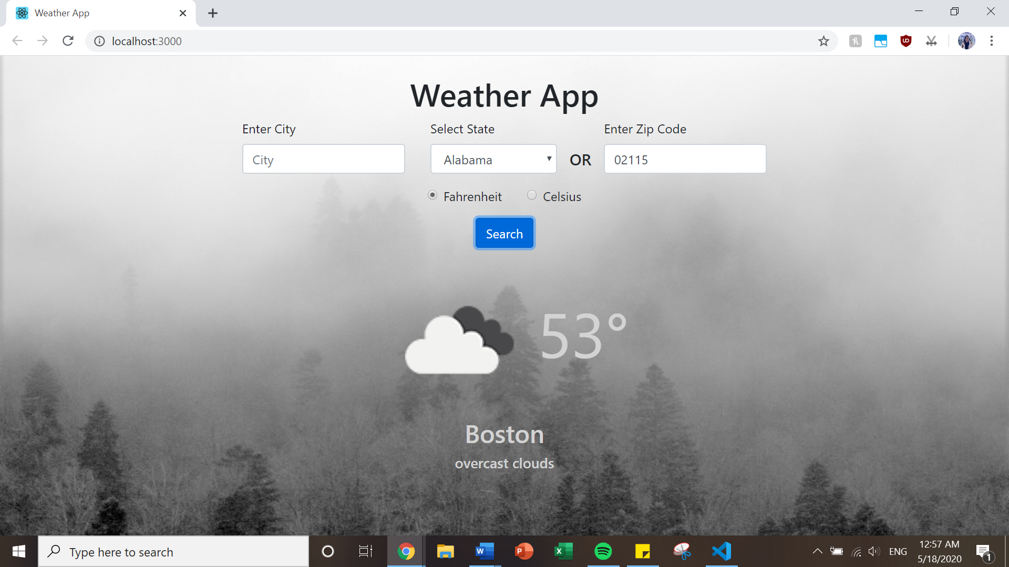

**Further Development:**

This project can be further developed by implementing more thorough error handling, displaying an error to the user and prompting them for valid input. There can also be a "Current Location" feature, using the user's device geolocation to make a call to the OpenWeather API with latitude and longitude as parameters in order to make searches more efficient. The "State" field is currently a dropdown list in order to reduce the possibility for user error. The "City" field can also be improved to autofill or display a dropdown of suggestions based on the user's input so far, further decreasing the case of user error.